October 21st, 2007
Hi
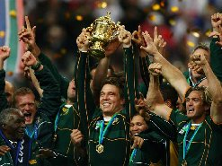
Well, the RWC is now over and South Africa are the champions, beating England last night in the final by 15 to 6, all the points coming from penalties. I did not watch the game as it begins at 3 am HK time, which is 9 pm Paris time. (So the match finishes at about 11 pm! Very late for a match but I suppose this time allows most countries around the world to watch the match at a reasonable time – though not HK!) In the playoff for third place a day earlier, Argentina beat France. So, SA have now won the cup two times, the first time being in 1995 in Johannesburg when they beat NZ by a drop goal in the last few seconds.
This past week I have not had so much work to do so have been able to have a bit more rest. On Monday, I went across to the public library (in the other building) to register. With HK’s new ID cards, the registration number can be placed on the card. I also borrowed a book; I think this is the first time in my life I have borrowed a book from a public library. The book was Volume 1 (of 3 big volumes) of the Sherlock Holmes stories. I also had a look around the library, which, considering this is Tin Shui Wai, is not too bad, with fiction and non-fiction in both English and Chinese as well as computer and audio-visual facilities.
The pattern of exercise this past week was slightly different. The three days I was in the gym I decided to include a little running as well, seeing that the hiking season is not to far away (with a slight decrease in skipping); so that meant 10 min skipping + weights (slightly reduced) and 10 min running. The other two days were for swimming. On the first day, I did 4.2 km, which I think is the most I have ever done (the previous longest being 4 km last year) and on the other day I did 3 km. This is an average of 3.6 km per day which is three times greater than the 1.2 km I usually do.
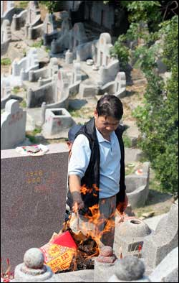
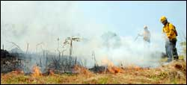
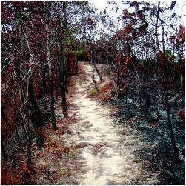
Friday was a holiday for Chung Yueng, which is the autumn grave-sweeping festival. Unfortunately the weather was very dry and there were about 90 hill fires, one of which burnt for about 10 hours!
Discovered that United Airlines is now offering tickets to San Francisco for about $4200 (mileage included) compared with the $5400 I paid! Annoying! Of course, if I had deliberately waited, it might have turned out that there were no cheaper tickets on offer and I would have had to pay a very high price.
That’s about it for now.
Cheers

Leonie: Suit measurements.
As you want me to hire a suit, here are the measurements. They were taken by me and not a tailor.
Height: 5’ 10½” (without shows)
Weight: 75 kg (165 lb) (don’t know if that is important)
Chest: 38”
Waist: 34~35”
Hips: ~35”
Legs (from waist down): 43~44” (without shoes)
Arms (from fingertip to fingertip with arms stretched out horizontally): 69~70”

